Integrating and Managing Pipedrive within WhatsApp
This guide provides step-by-step instructions on how to connect your Pipedrive CRM to WhatsApp and efficiently manage your sales activities directly from your chat interface. Learn to, connect the integration, and utilize features like adding notes, tasks, and creating deals without leaving WhatsApp.

Open the WhatsApp web with the Eazybe Extension installed.
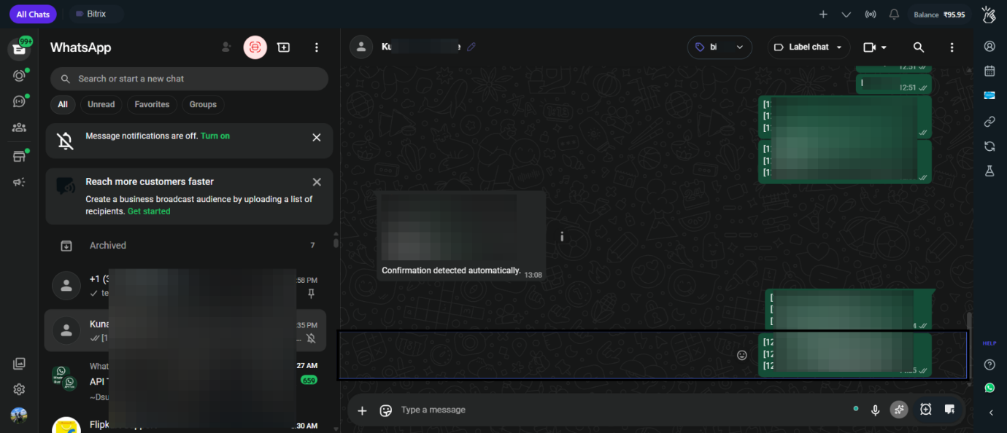

Click on the CRM/Integrations button and navigate to the Pipedrive and click on " Connect ".
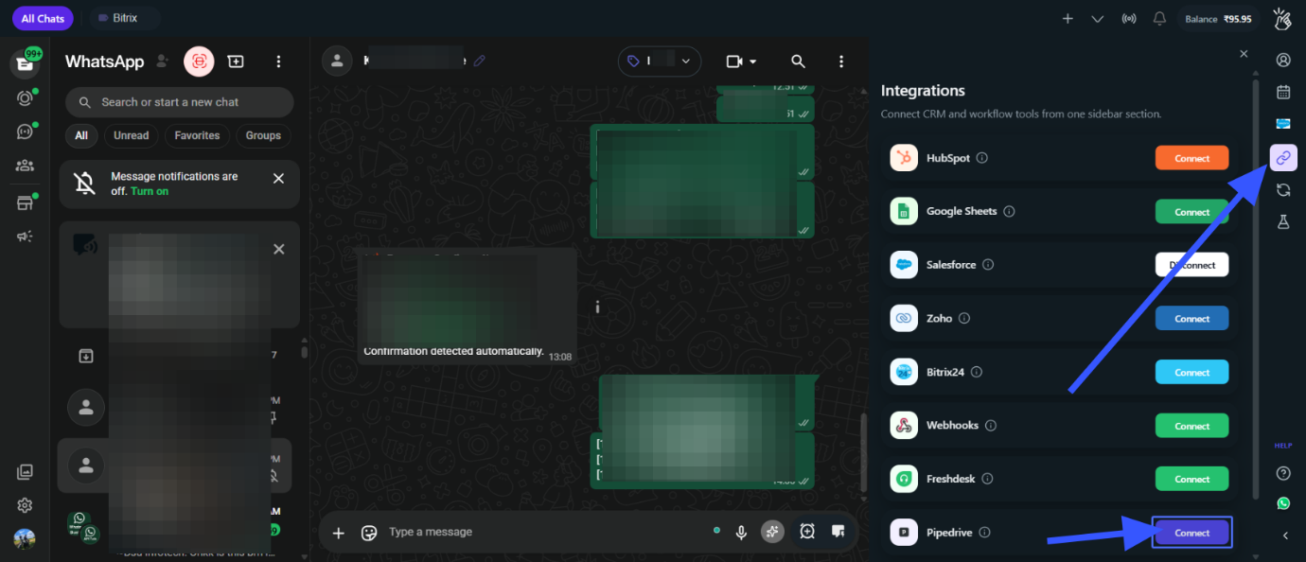

For Integration , you need your Company Domain ( This is just the subdomain in your Pipedrive URL. When you're logged into Pipedrive, look at the address bar — it'll read something like https://yourcompany.pipedrive.com. The part before .pipedrive.com ) .
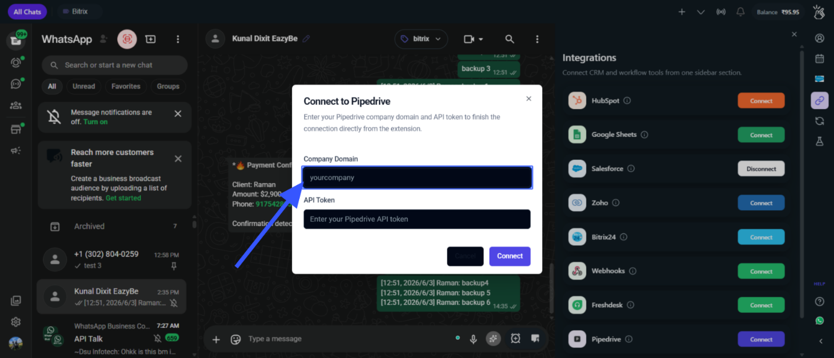

Then you need your Pipedrive API Token
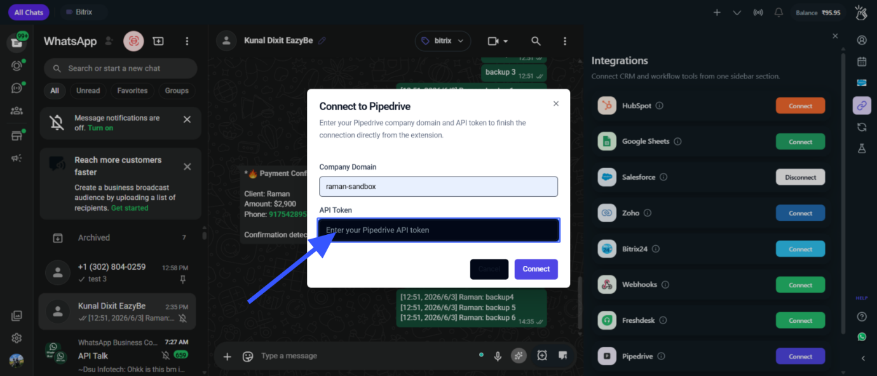

To get the API Token , Go to your Pipedrive account , then click on Personal Preferences, then click on the API tab , Under API Tab you can either copy your existing API Token on Generate new token
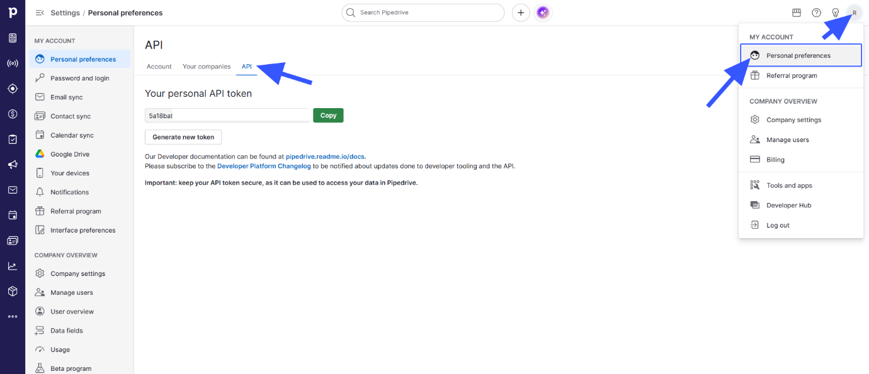

Past your Pipedrive API Token and click on Connect.
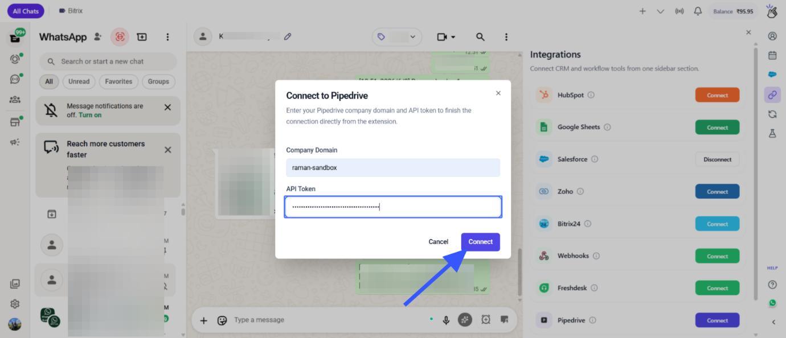

To Disconnect you can click on this " Disconnect " button.
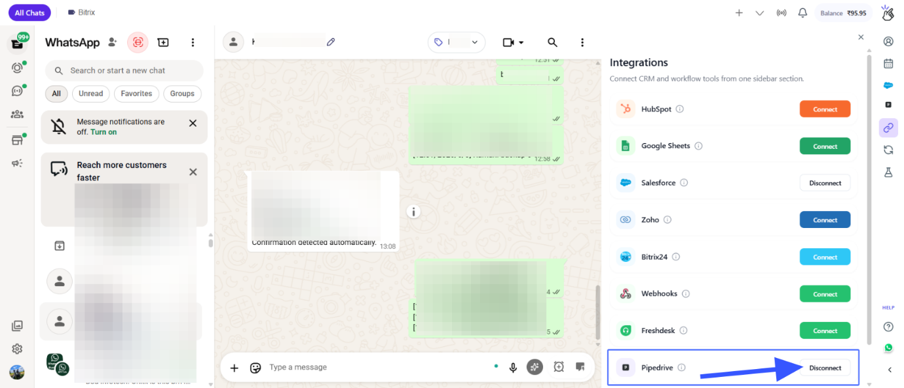

Click on the "Pipedrive logo " to open the Mini CRM
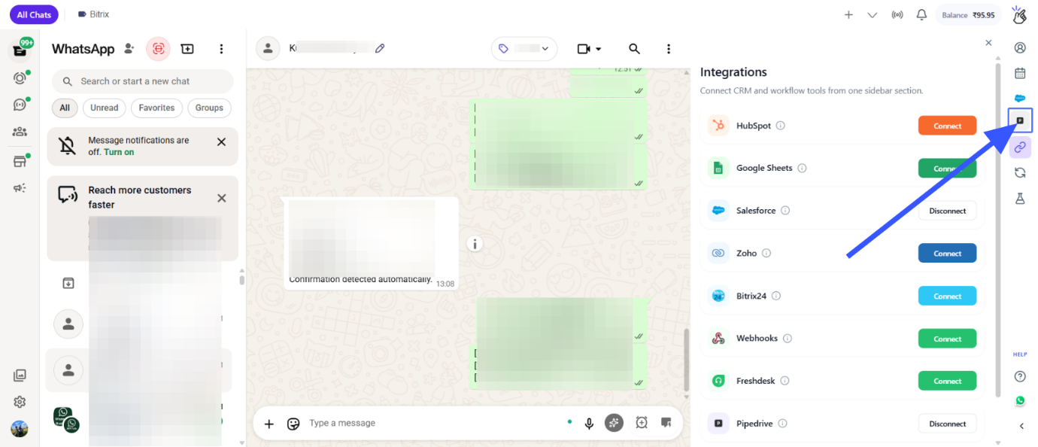

Under Mini CRM, you can create the contact , Notes, Tasks, Deals based on the opened Chat.
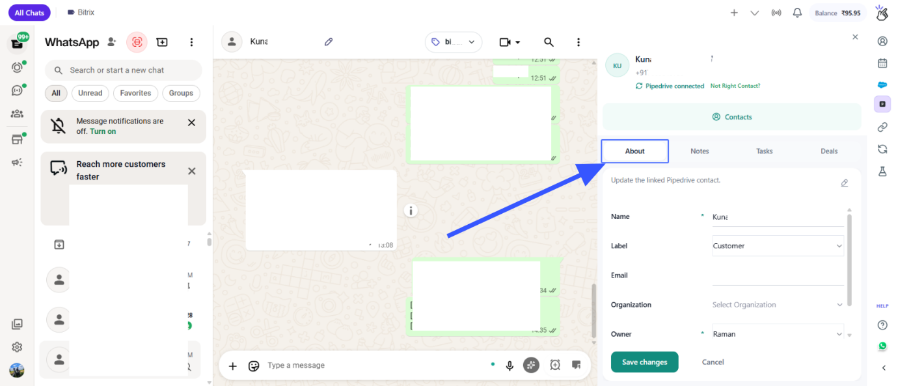

One Click contact redirect button , This will directly open contacts Pipedrive page
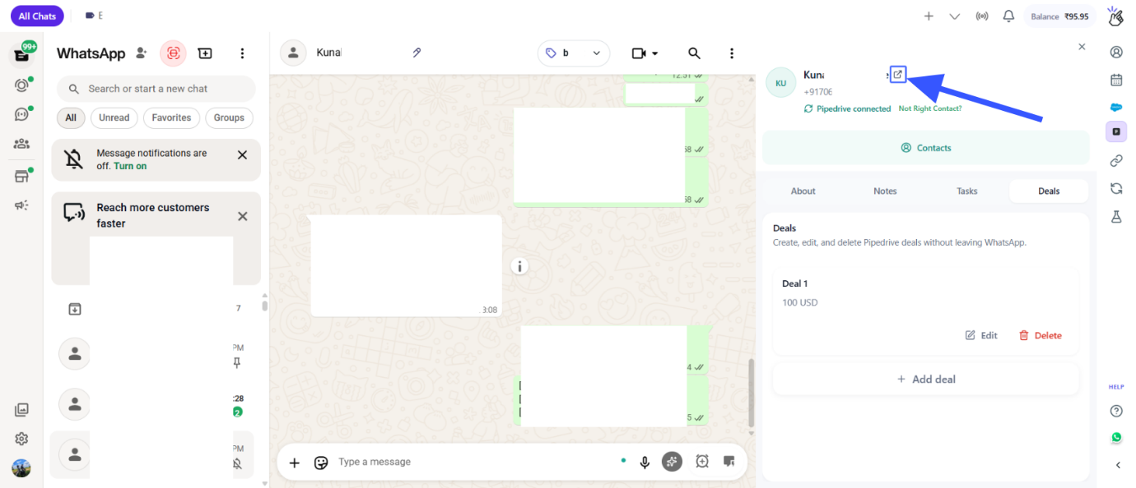
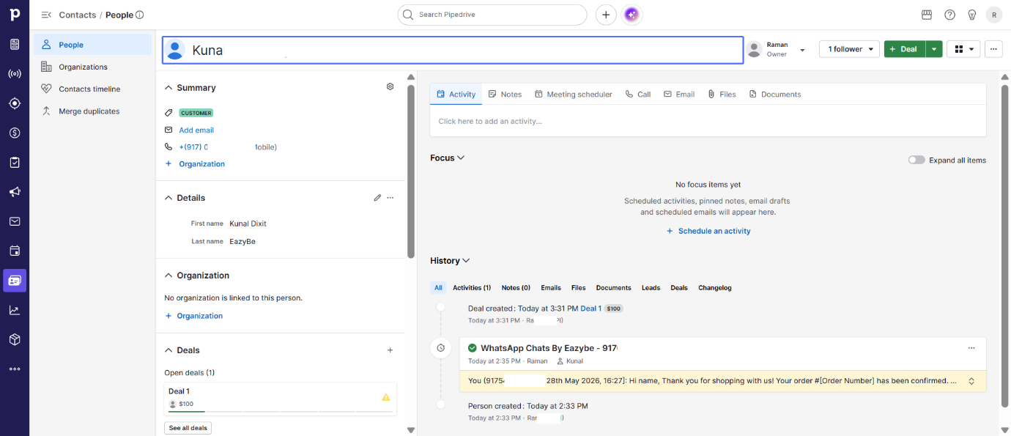

Chat backup view under contacts.
